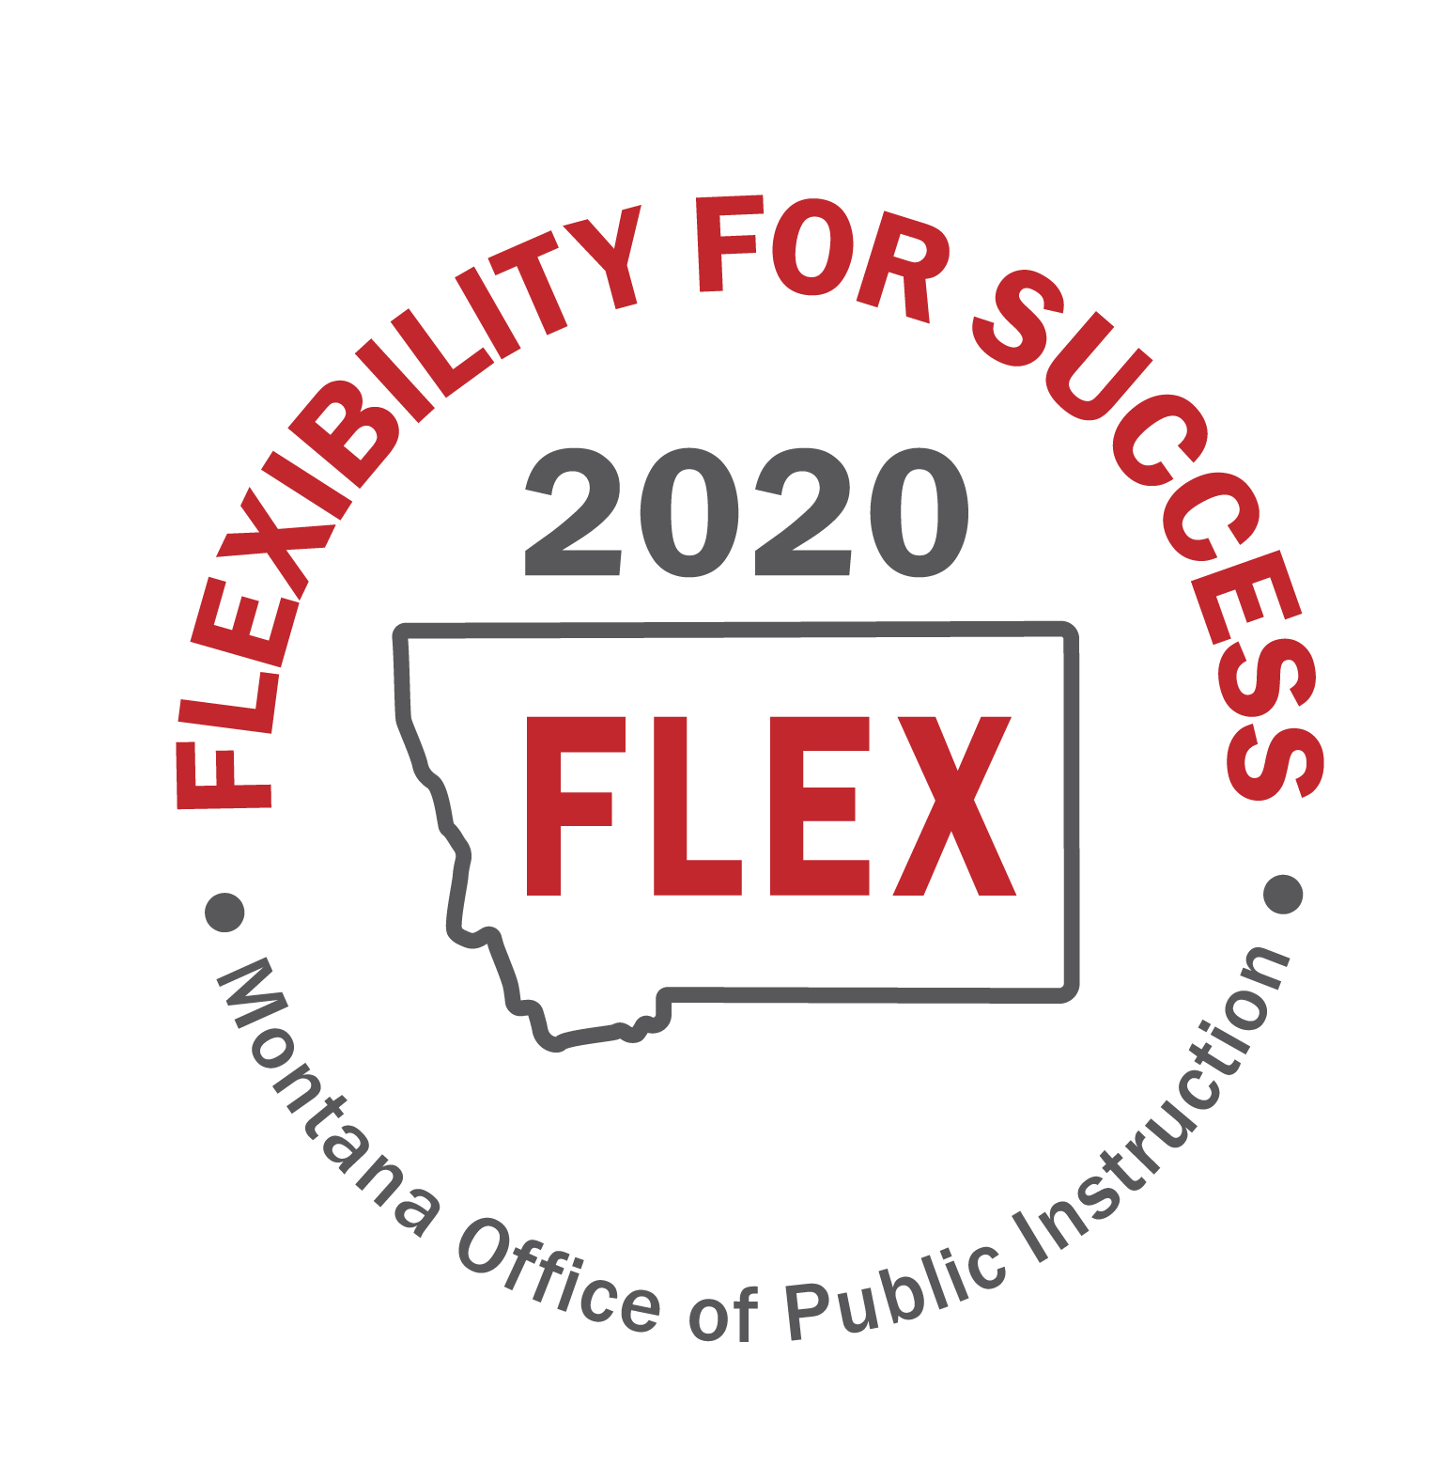

“MT FLEX2020” Task Force

Focus Group Recommended Flexibilities
Summary Sheets

Purpose: Focus on flexibilities- Promoting opportunities for student success by seeking waivers on identified systematic barriers as our schools prepare for the Fall of 2020.

Focus Group | Recommended Flexibilities | Priority | Action Steps/Notes
- Strengthening Existing policy flexibility | 1. Provide a Holistic CURRENT FLEXIBILITIES Cross Walk Guidance Document | Crucial Do Now | Produce a cohesive guidance document on existing flexibilities.
- Strengthening Existing policy flexibility | 2. Eliminate Aggregate Hours | Crucial Do Now | Create new waiver that eliminates seat time or aggregate hours (current statute comes close, but needs more)
- Strengthening Existing policy flexibility | 3. CTAE licensure flexibilities | Uncategorized
- Strengthening Existing policy flexibility | 4. Guidance for proficiency models that address proficiency scales tied to Content Standards that could be applied to blended learning models, create student interest course of study, etc. | Uncategorized | Creating guidance on proficiency models.
- Strengthening Existing policy flexibility | 5. Flexibilities to Use Local Assessment Data rather than Federal Mandated/State Mandated Testing | Crucial Do Now | State and federal waivers to use local assessments rather than large.
- Evaluating progress and impact of state graduation, credit, funding, licensure, and accreditation policies | 1. Flexibility within the accreditation variances of standards and review board process. | Crucial-Do Now | - Flexibility within the accreditation variances of standards and review board process  - 10-55-604 process outlined for the board takes effect at beginning of SY - make it ongoing pre-appointed review board  - temp or perm look at composition of review board - should it be CSPAC which meets four times a year?  - CSPAC would review with OPI and recommendations to the BOPE for action. Speed it up.
 | 2. Collective Bargaining Engagement: Guidance for helping local boards engage in the collective bargaining process. | Uncategorized
 | 3. Licensure Flexibilities: Produce a one-page summary of the flexibilities available in licensure to help administrators understand about emergency authorizations, what it takes to get an out-of-state teacher licensed, the Praxis issue, around 10-55-607 and 10-55-604, and still apply the checks and balances to get quality teachers. | Crucial-Do Now
 | 4. Accommodating teachers in the high-risk health category who can’t come in the classroom. | Crucial-Do Now
 | 5. Getting technology to students | Crucial-Do Now | - home connectivity is also an issue  - some districts didn't have tech devices, equipment, connectivity to get to students  - MT broadband Advisory cmte has data on school connectivity - may expand to community connectivity - access level, cost to provide  - legislative consideration - cost to provide broadband to communities  - cost to provide devices/equipment for equity in delivery  - Legislative priority - move tech levy from voted to permissive - districts could then permissively levy to supply on-line learning  - remove time limit on tech levy (extend sunset)  - flex in fund movement so funds could go into technology expenditures (as in LM presentation)  - flex to let districts take loans, then use maintenance funds to pay down loans  - Browning bought jet packs - another good option  - common platform statewide for online delivery - seamless when kids move back and forth and when districts cooperate  - PD would have to be a piece of this  - ND has a common platform - have to balance with local control - but possibly something the SEA can provide and pay for  - HAVE to protect online student data in any online platform - Zoom, for example, would need to contract with each district  - Be flexible with MDA - start and stop times need to be more flexible  - Any additional functionality for MDA means additional resources to MDA  - MDA relates to middle and high schools only  - New VisonNet?  - Districts sharing teachers now - look at flex in rule to be able to do that  - also look at CBA so teachers can do that  - distance learning rules are flex right now; must have licensed teacher and a para to monitor and assist at the distanced schools  - flex in the TEAMS report - how to count FTE
 | 6. School nutrition flexibility | Crucial-Do Now | Move to Group E
- Maximizing flexibilities in assessment, accountability and reporting systems | 1. Federal Waiver for Standardized Spring Assessment 2021. | Crucial-Do Now | Action Plan:  Model the waiver process from the Assessment Waiver that occurred this past Spring. Request for the Superintendent to apply for the waiver from the USDE. Recommend—issuing a Letter of intent now to the USDE that MT will be seeking a waiver on assessments. Then, follow the regular protocol for seeking waivers: Public Comment-30 days, Conduct Governor Consultation, Superintendent letter, and Red-Lined version of the ESSA plan if needed. We recognize that the USED would have 120 days for response. Given the time to get the waiver process completed, we recommend drafting the waiver and initiating the process ASAP--getting it out for public comment.  Potential Risks Shared:  - Perception of avoiding accountability—especially if seen as early in the COVID response and that we used the COVID situation to get out of being held accountable.  - If we seek a waiver for another year on assessments, we would lose comparison data across districts and nation.  - Include assurances in the waiver--Local School Districts would use local assessments to ensure that student learning is being monitored, this could also help address remediation-closing the gap formed from response to COVID. We will have to track trend data through local assessments.  Implications:  - Regardless of the future waivers, based on this last Spring, we will be starting over again to have reliable, standardized data.  - TSI/CSI exit criteria—no data to get out of it.  - Funding for improvement that is based on the status—would it continue? Note: School size does impact the funding consideration for CSI and TSI.  Considerations to address prior to drafting the waiver:  - ACT—HS impact may be different than ES-SBAC—because the ACT does not correlate to the standards like the SBAC does with ES standards. We want students to be able to take ACT, but it does not provide perspective on standards.  - From a Financial standpoint: What is the impact of the current waiver on the assessment contract? How long is the contract—multi-year? Can it be amended?
 | 2. Assessment Considerations for School Year 2020-2021 to use local assessments to measure and report student academic growth. | Crucial-Do Later | If the first waiver on Assessment is approved—this would need to immediately follow. It is contingent on the first waiver approval.
 | 3. ESSA State Plan Amendment for entrance and exit criteria for CSI/TSI/ATSI schools that addresses the disruption to the system and holds schools harmless, while providing time for the stakeholders to restore and improve the accountability system for 2020-2021 and beyond. | Crucial-Do Later | Regardless if the Assessment waiver is approved, how will we ensure that CSI and TSI schools are held harmless? Can the accountability system be restarted—and can we have a planning year to revamp and enhance the whole accountability system? Could a waiver for a gap year for standardized assessment, accountability and report card be completed as a bundle? Giving one year to freeze the system and rebuild all together.
 | 4. Federal Waivers to reporting requirements for the report card. | Crucial-Do Now | Seek a waiver to not have a report card issued for the 2019-2020 school year. Without data the report card becomes in-valid or not a true representation of a school’s performance. For example, the PPE will be skewed based on CARES Funding. There is no assessment data. The Public will lose faith in what the report card represents, which impacts future report cards relevance, dependency and use.  Other Consideration:  Potentially do a special edition for the report card for the 2019-2020 year, reporting out on the impact of COVID. Use a model to provide transparency on ESSER funding. Example: This is what we are doing with the ESSER funding to address the impact of COVID19. Communicate clearly around what services have been provided, increase in tech, or staff PD, facility and safety measures. Opportunity to communicate the percentage of students who participated in remote learning, in face learning, etc. This could also be an opportunity to present some local data. What assessment tool did you use to measure student regression and student growth over the year, and growth goals for the year.  Risk: Not necessarily publishing the percentages of student proficiency but rather overall student growth in math and ELA--because of different scales for proficiency.
- Fostering and supporting local innovation | 1. Expand the Transformational Learning Bill for remote and blended learning models. The grant process needs to be funded in a way to have more applicants. Self-directed philosophy is needed. | Crucial-Do Now | - Align transformational learning with assurances standards  - Stakeholder engagement  - Share a comprehensive document with existing flexibilities  - Expand Transformational Learning opportunities  - Review of first-come, first-served process/alternatives
- Fostering and supporting local innovation | 2. Legislative considerations or waiver process that empowers Districts to design their own Innovative paradigm/model that fits their community needs; bundles local, state, and federal flexibilities; and provides time for school communities to plan, implement and evaluate the new paradigm. | Crucial-Do Now | - How to incorporate flexibilities into EOPs or emergency declarations  - Desire for specific examples of what districts can’t do- what are actual barriers and what are perceived barriers  - Student seat time- pupil instruction hour requirement flexibility/attendance  - Multi-student households and strain on technology
- Fostering and supporting local innovation | 3. Request OPI to set up regional support teams and PD for Blended Learning, Remote Learning, and Personalized Learning and Leadership Networks. | Uncategorized
- Fostering and supporting local innovation | 4. Develop avenues for Parent and Community Resources and Tools for Remote Learning | Uncategorized
- Leveraging Federal Flexibilities and Resources | 1. Federal Funding Flexibility Waiver for Title I, Part A to address eligibility and carry-over. | Crucial-Do Now | First issue: Waive any carry over limitations for this year and next year. OPI would need to make the request of the waiver to the USED.  Second: Can all Title I Targeted Assistance schools function under  schoolwide requirements for 20-21 school year? Ed Flex program does address carry over from year to year so could this be an option without getting a waiver? Could we ask for the Targeted Assistance flexibility under Ed Flex? Is this an appropriate use of Ed Flex or do we need a second waiver? OPI would need to find out and make the request and then we wouldn’t need a waiver.  Third: Is there flexibility in lowering the free/reduced rate to qualify for Targeted Assistance for 20-21 school year. Can OPI seek answers to this?
- Leveraging Federal Flexibilities and Resources | 2. ESSA State Plan Amendment for MT State Flex Indicator #5 to eliminate attendance factors. | Crucial-Do Later | Can we get the 5th Indicator of the Accountability System waived for the COVID time period?  What are other states doing?  Will USED allow us to not do all 5 criteria?  OPI might need to do a survey to find out what other data could be used?  ESSA plan needs to be updated.  We need to look at what we do have data for regardless of in building or remote learning to determine a better fit.
- Leveraging Federal Flexibilities and Resources | 3. Federal Funding Flexibility Waiver for Nutrition. | Crucial-Do Now | First: Is the Summer food service program available for 20-21 school year for a blended or remote school model. School nutrition needs to explore this.  Second: Continue non congregate waiver so families can access food and take home.  Third: Can we have a grandfather clause that any community eligibility for this year could carry over for next year. There are a lot of kids currently certified through direct certification, but some may lose eligibility due to Medicaid work requirements. Now, many of those kids will have to fill out the paperwork and we are concerned we will have a gap. We can do administrative certification on some. Losing direct certification would impact our community eligibility. Has CEP already been determined for the 20-21 year? Do we need to look beyond?  Fourth: Communication resources for schools to use to talk with parents about the importance of filling out the paperwork even if they are not going to take advantage of the nutrition services because it impacts the schools free/reduced rate.
- Leveraging Federal Flexibilities and Resources | 4. Potential partnership with MT Digital Academy to support remote learning. | Crucial-Do Now | Make requests to MT Digital Academy that they extend periods of enrollment and remove deadlines.  Make request to Mt Digital Academy to stretch down below 6th grade as 4th and 5th grade students sometimes get lost.  For small districts: Make request to Mt Digital Academy to see if they would run a class by grade level for those schools that have a handful of students that want remote learning and the teacher can’t do both. District could pay tuition out of ESSER funds. Mid-size districts could form a cooperative for a similar service.  Can the school still collect AnB if the student is doing remote learning.  Partner with TRS to do a waiver for recently retired teachers to teach in digital academy to help with the teacher shortage.
- Leveraging Federal Flexibilities and Resources | 5. Leverage federal telecommunications funding and assistance programs, like E-Rate, to get devices and internet access for students. | Crucial-Do Now
- Leveraging Federal Flexibilities and Resources | 6. Federal waiver for Civil Rights Data collection. | Crucial-Do Later
- Leveraging Federal Flexibilities and Resources | 7. Waiver to transfer funding for transportation to afterschool and 2021 summer tutoring programs. | Uncategorized

